**SCNI/01298/2021**

**TAFF NYAMITA**

**ASSIGNMENT 4: SOFTWARE DEVELOPMENT**

**SYSTEM MODELLING**

1.Pick an appropriate software engineering methodology.

Agile Methodology:

Agile methodology such as Scrum, is well-suited for projects with evolving requirements and a need for flexibility. This methodologies emphasize iterative development, frequent communication, and collaboration. Agile methodologies can work well when developing a food timetable planner as they allow for continuous feedback and adjustments based on user needs and changing dietary requirements.

This therefore makes this methodology ideal for developing On-point software to utmost effectiveness.

2. Your system uses cases ,come up with the following system modelling schemes.

**Context model.**

This model basically shows an overview of a system and its interactions with external entities

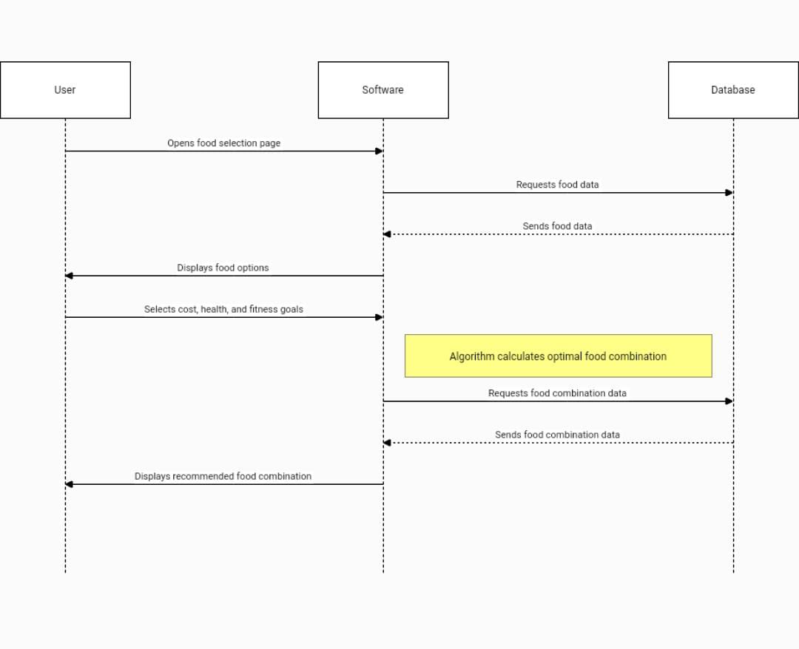

**Behavioral model**

*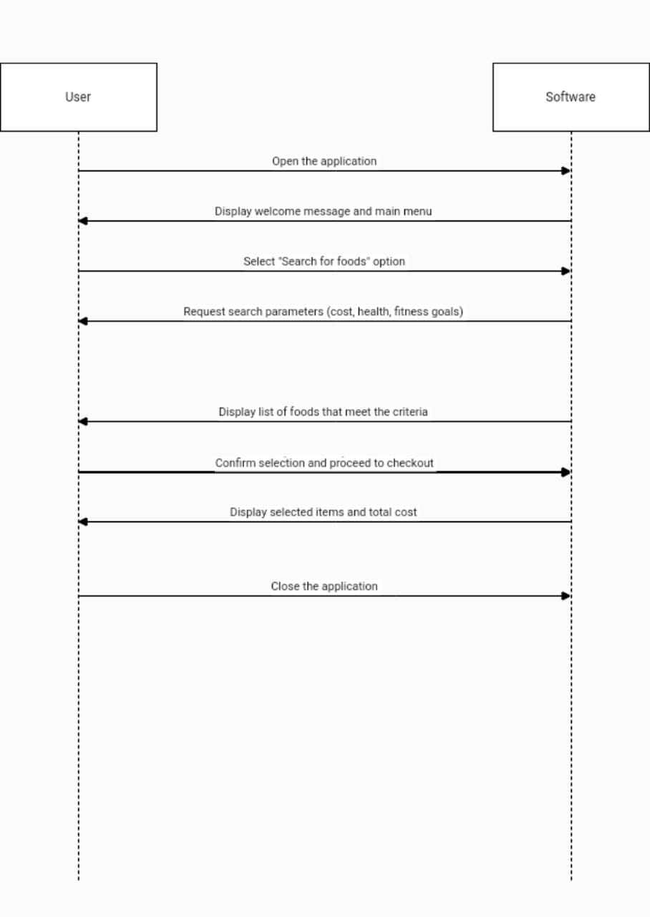.*

**Structural model***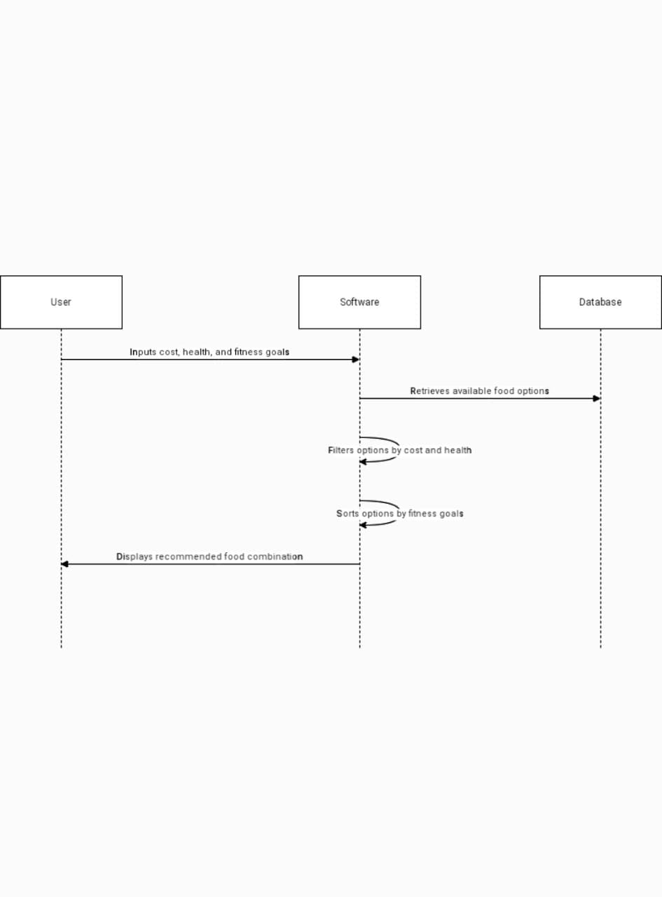*

**Interaction model**

